Reflection

Ward Ovezall – 13415875

Modelling for Sustainability

UvA – Amsterdam

**Combination 4.**

**Table 7 Table 8**

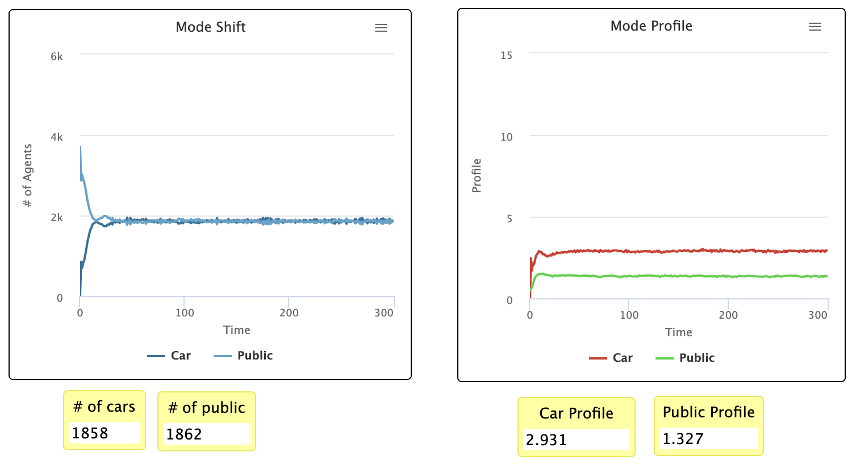

**Combination 5.**

**Table 9 Table 10**

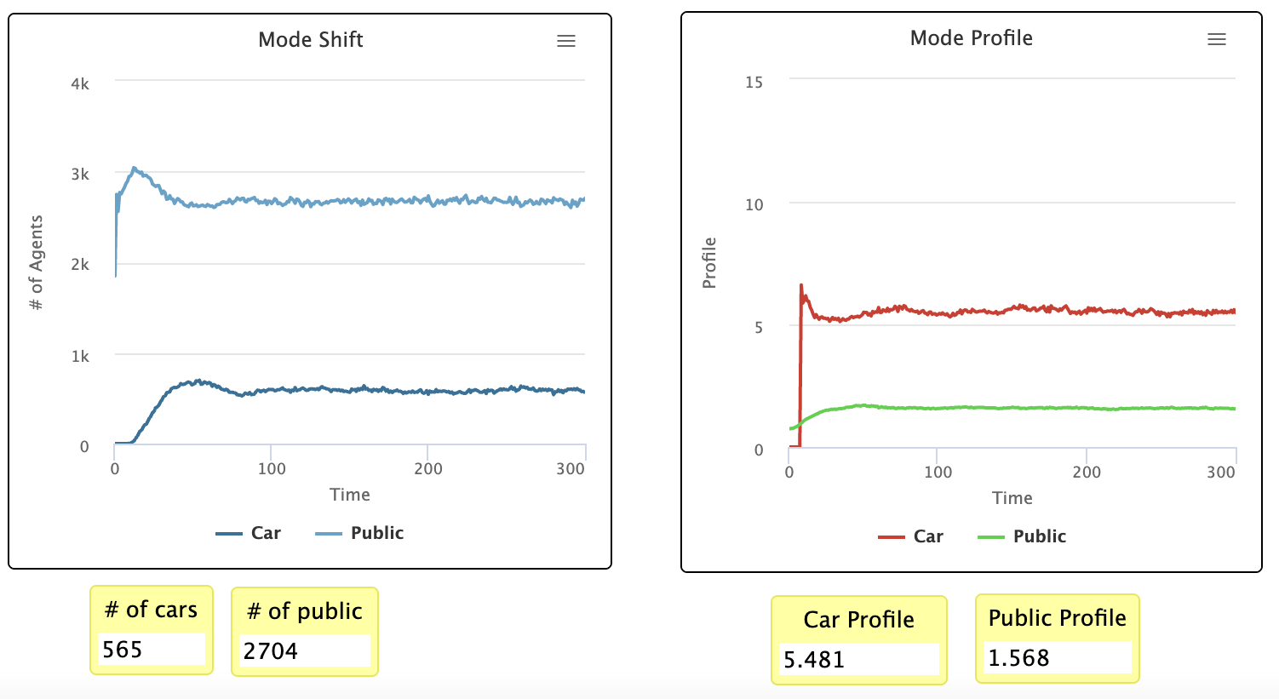

I will be reflecting on the output graphs of the fourth combination that we made in order to simulate the effects of a zero-fare policy on the use of cars and public transport. I also added combination 5, as this combination served as a control group, visualizing the situation as it would be if there was no zero-fare policy at play. This way we could compare the differences in car- and public transportation use and observe whether or not such a policy would have a significant positive effect. In the model, we had two more parameters that we thought were of importance to control for based on our theoretical research. The first one being the buying price of a car, and the second one being a threshold parameter, which controlled for the perceived utility of using public transportation. The parameter settings we used for both combinations were as such:

|  |  |  |  |
| --- | --- | --- | --- |
|  | Fare | Buying Price | Threshold |
| Combination 4 | 0 | 2.5 | 0 |
| Combination 5 | 0.5 | 2.5 | 0.5 |

What changed in combination 4 compared to combination 5 is that the public transportation fare decreased to zero and the perceived utility of public transportation decreased to zero. The buying price of a car remained the same. I’m not going to elaborate a lot on how the results of combination 5 can be interpreted, but the results of combination 4 are quite interesting.

The amount of cars used and the amount of people using public transportation share about the same value after stabilization. Use of public transportation decreased, and use of cars increased. This means that the Threshold parameter holds a stronger value when it drops to zero than the Fare parameter does. Even though car use increased, the prestige value of using a car decreased significantly, whereby the prestige value of public transportation remained about the same.

Now a big limitation in our modelling and output interpretation is that we cannot exactly find out what the magnitude of the effect of each parameter is compared to the other ones. But increasing the amount of combination used in our research would only result in additional complications interpreting each effect. If further research with this particular model setup would continue, I would also like to see additional parameters being added, since there are a multitude of factors influencing consumer’s choices towards mode of transportation. Within the scope and time limits of our research, we were not able to alter the model in such ways where we could find a way to control for more variables.

Improvements could be adding more parameters and refining/altering the parameter values to cohere more to each other. This could result in more realistic model outcomes.